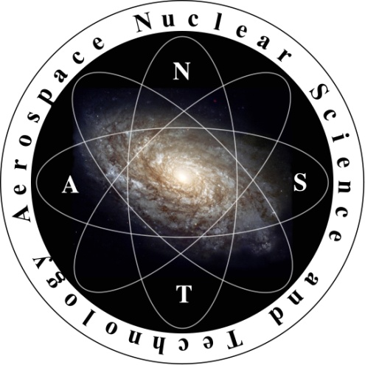

American Nuclear Society
Aerospace Nuclear Science and
Technology Division
(ANSTD)

Purpose: Established to promote the advancement of knowledge in the use of nuclear science and technologies in aerospace (air and space) applications.

The ANSTD Vision

The ANSTD seeks to advance the applications of nuclear energy in aerospace nuclear technology for use in safe space exploration. ANST provides a unique opportunity to expand frontiers in nuclear science and technology, and serves as a catalyst to revitalize broad support for the peaceful use of nuclear energy, increasing public education and awareness, and attracting young talents to the nuclear profession.

The ANSTD began as an ANS Technical Group in 2000. Through the work and dedication of its founding members (many of whom are still active), the ANSTD became an American Nuclear Society Technical Division in 2008. Since that time, the ANSTD has achieved several significant goals:

- Support ANST-related technical sessions at the ANS national meetings,
- Establish the Nuclear and Emerging Technologies for Space (NETS) conference as the premier ANST technical and topical conference,
- Maintain an annual membership of over 500 or about 5% of the overall ANS membership,
- Demonstrate over 40% student membership – a statistic indicative of the excitement and interest younger people have for space nuclear applications; and,
- Provide regular and strong support of student participation at the national and student conferences.

Visit us on the web at:
http://anstd.ans.org

Check out our space nuclear blog posts at the ANS Nuclear Cafe:
http://ansnuclearcafe.org keyword: ANST

Previous web and blog topics:

Introduction to Space Radiation

The existence of space radiation plays an important part in planning space missions within low Earth orbit (LEO) and beyond. Space radiation has the potential to negatively impact several aspects of space missions, whether manned or unmanned, within in LEO or farther into space. Radiation can be detrimental to the health of astronauts, increasing the risk of cancer and genetic mutations, and to electronic equipment functionality, decreasing the lifetime of important electronic equipment and/or resulting in total electronic failure. As a result, protection against space radiation is vital to the success of any space mission, especially missions outside of Earth’s magnetosphere. …continued online on the ANSTD web page!

Space nuclear propulsion: Humanity’s route to the solar system
Part I: Space nuclear reactor safety

Though humans have successfully traveled from the earth to the moon, our exploration of the remainder of the solar system has been limited to robotic space probes which, once set in their trajectory, are not designed to return to earth. The data returned from these probes has been of tremendous importance for our understanding of the solar system and regions beyond, but human exploration beyond earth’s orbit remains to be achieved. There are a number of concepts currently under study that would allow us to break out of earth’s gravity well. The most studied and discussed are nuclear electric propulsion and nuclear thermal propulsion.
…continued online at the ANS Nuclear Cafe!

Plutonium in Space: Why and How?

The reasons for using plutonium in space missions are often unclear to those outside the mission planning community. Observers may see or hear only that the space mission is nuclear related, and that the power source uses plutonium. Plutonium is a word that in some communities has very negative connotations. On the other hand, it is also the element that has been used to safely power many space missions, including the Voyager, Galileo, Cassini, New Horizons, and the most recent Mars rover, Curiosity.…continued online at the ANS Nuclear Cafe!

Upcoming ANSTD Sponsored and/or Co-Sponsored Technical Sessions

ANS 2014 Summer Meeting (Reno, NV)
- Nuclear Criticality Safety and Space Technology Applications
- Thursday, June 19, 2014, 1:00 pm to 3:05 pm, Crystal 3

ANS 2014 Winter Meeting (Anaheim, CA)
- 2a. Aerospace Nuclear Science and Technology: General
- 16c. Tutorial on Radiation Protection and Shielding in Aeronautics and Space Applications
- 16d. Physics of Compact Reactors for Terrestrial and Space Applications
